Bambelela is a privately owned and operated wildlife rehabilitation and conservation centre in the Waterberg district. It is well known and especially well regarded for its exceptional work with Vervet Monkeys.

Bambelela was established in December 2003 by Silke von Eynern with the aim of reintroducing wildlife into the Groot Nylsoog area of the Waterberg district. Together with Rodney Williams Silke purchased five Blue Wildebeest, but upon their arrival quickly determined that the animals were only a couple of days old. One died that first night but with the advice and assistance of Brian Jones from Moholoholo (“The Very Great One”) Rehab in Hoedspruit, they managed to pull the other four through. From that rocky start, they began taking over the care of animals from Moholoholo that were almost ready for release back into the wild and in doing so, recognized their true calling: to help wild animals in need.

People from the Waterberg district learned of their work and started to call upon them for help, as did the veterinarians from the region. They became well known and well regarded as a Rehabilitation Centre and have successfully rehabilitated and released many different species, including Eland, Kudu, Impala, Red Hartebeest, Nyala, Blue Wildebeest, warthogs, bush pigs, Serval cats, zebra, yellow-billed Kites, black-back jackals, porcupines, and many more. Even a orphaned Rhino-baby made its way to Bambelela and is now a sub adult and living free.

A few years later a young female Vervet Monkey was left behind in a cage without food or water on a property outside Bela Bela and has been brought to Bambelela. A few days later, a neighbour dropped off another young Vervet and then, a Vervet baby made its way to Bambelela, too.

By now Bambelela is still caring for all kind of wildlife but concentrating mainly on the rehabilitation of Vervet Monkeys. Every year 20-25 orphans arrive and are being hand raised at Bambelela and older Vervets coming to Bambelela are either injured or often transferring males ending up in human habitats. Since 2008 eight troops of Vervet monkeys have successfully been rehabilitated and released on different Bushveld farms in Limpopo where they are living free.

Silke gained a lot of knowledge about those primates due to the late Rita Miljo from C.A.R.E, the Baboon Rehab in Phalaborwa and Bambelela also functions as a half-way house for orphaned and injured Baboons.

Bambelela also aims to educate people about the value of free roaming monkeys and to show ways of living together in harmony. To do so they offer tours through the wildlife centre for day-visitors and chalet-guests as well as interaction with pinkface-monkey babies (during season).
Bambelela also offers help to self-studying FGASA students and long term volunteers for theory and practical FGASA exams.

Being a privately owned and operated organisation Bambelela relies heavily on paying volunteers from all over the world, chalet-guest and day-visitors which are beside a “Guardian Angel Program” and public donations the only source of income.

At the moment Bambelela runs the rehabilitation centre still at a monthly loss but it’s hoped to become fully functioning and financially self sustaining by the end of 2013. The more, Bambelela is on the way to register as a non-profit organization or foundation. Until then it falls under DIY-Wild and tax-deductable donations can be done via Charity No: 099-008NPO “Helping hands for wildlife NPO”.

THE ECOLOGICAL VALUE
OF VERVET MONKEYS

The Vervet Monkey [Chlorocebus formerly known as:Cercopethicus aethiops], is one of our biggest ecologists in nature, they are vital for the survival of our environment and, although since April 2005 no longer declared as “Vermin” in the Limpopo Province, their numbers still keep on dwindling rapidly. Our interest as human primates is in constant conflict with the interest of non-human primates such as Vervet Monkeys and Baboons.

The value of free roaming Vervet Monkeys is priceless, they play an important role in creating a balanced, healthy environment for us. The Vervet Monkey Ecologist help create balance in our environment via:

- Bird control
- Insect Control
- Spreading of seeds
- invasiability
- biotic interaction
- sustainability
- Pollination of plants

Bambelela wants to conduct research into Vervet Monkeys by observing their behavior pattern in order for a better understanding of their nature. They want to make the public aware of the fact, that we humans are destroying this vital species through littering, offering them food, destroying their natural habitat and mindlessly trapping and killing them. There is a 39% decline in Vervet Monkey population and 59% decline in Baboon population, despite the general public believing their numbers are “exploding”.

The children of today, who will be the future of tomorrow, must get involved in Nature Conservation through education and understanding where, why and when the problem began and look at alternative solutions to the few cents for a bullet to kill the primates. People need to learn about primates’ social behavior patterns in order to gain an understanding of these magnificent creatures and thus find solutions that benefit man AND MONKEY.
Human and Non-Human Primates can live in harmony and peaceful co-existence to one another, if MAN wants.
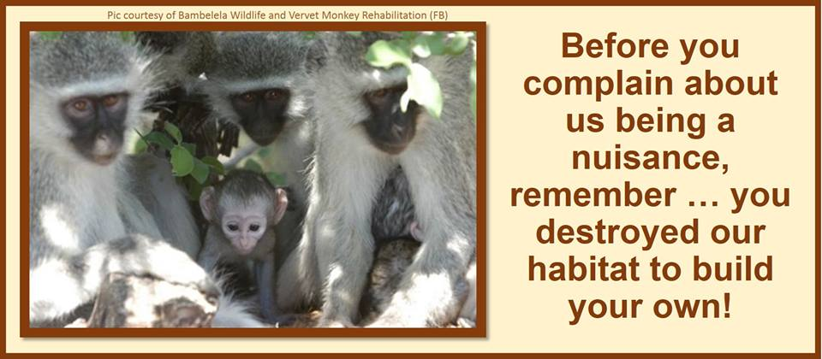
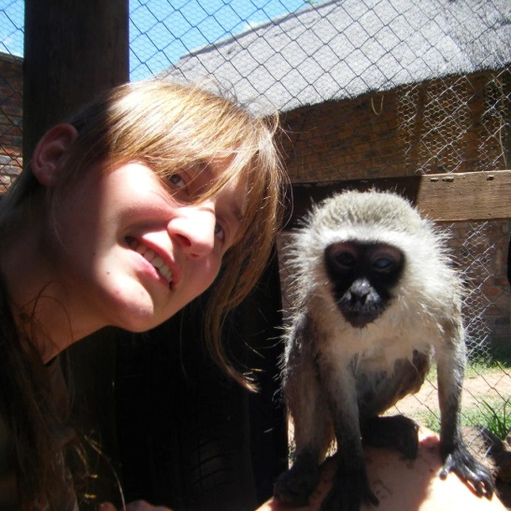

My Bambelela

My Name is Janina Lebdowicz and I’m from Switzerland. I studied the first 3 years of veterinary medicine at the University of Bern. Because I struggled with the exams I decided to take a gap-year and make up my mind how to carry on. This brought me in October 2012 to Bambelela where I volunteered for 3 months. I immediately fell in love with this place – especially with the monkeys I took care of.

It happened that there was an internship available as caretaker for the cage I was already working with and so I took my chance. Beside the daily work with the monkeys and on the farm in general I also got the opportunity to study for the FGASA-Field Guide exams and I recently passed the theory and practical exam for Level 1.

My aim is to keep on learning about South Africa and its beautiful nature and wildlife as well as helping to protect both. I’m proud to be part of the Bambelela-Team as well as being a FGASA-Member and a future Field Guide.
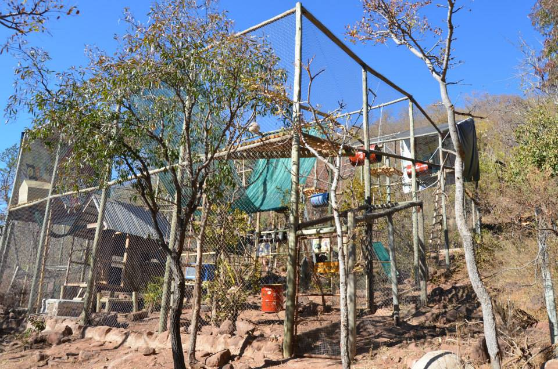
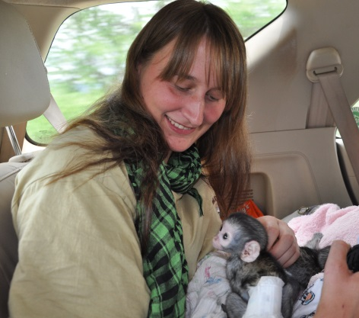
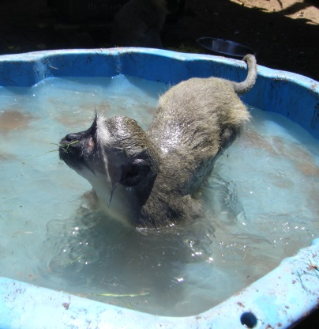
Monkeys love to swim Rescuing a pinkface monkey - they need Rehab-Enclosures are big and full of moveable
lots of love and company of their own kind. objects to prepare the monkeys for the wild.
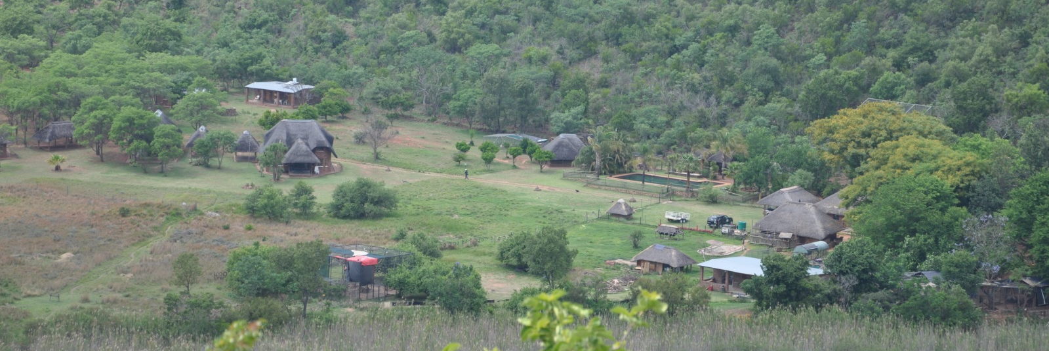
A view on Bambelela from the top of the mountain.

